姓名 | Chai, Zhiping
教育与工作经历 | Dalian University of Technology, Bachelor’s degree, 2015-2019  Huazhong University of Science and Technology, Master’s degree, 2019-2021  Huazhong University of Science and Technology, Doctoral degree, 2021-2026
电子邮箱 | zhipingchai@hust.edu.cn
个人照片 | 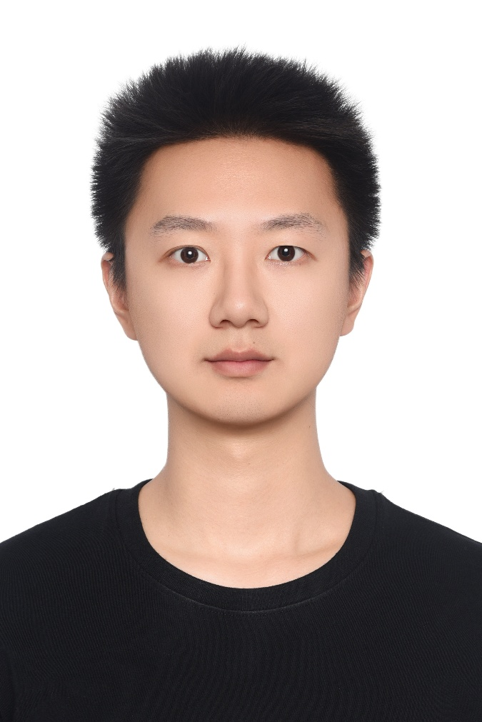
研究领域 | AI for Science and Data-Driven Physical Modeling;  Embodied Intelligence for Flexible-Rigid Coupled Robotic Systems;  Multimodal Perception and Intelligent Robotic Manipulation;
自我介绍 | I am a visiting scholar at SUSTech. By integrating physics-based simulation, data driven modeling, and generative architectures, my research interest bridges the gap between computational intelligence and real world physical systems.
论文发表情况 | https://scholar.google.com/citations?user=74VjAf0AAAAJ&hl=zh-CN
填写参考：https://bird-lab.org/people

